Assignment -4

SMS SPAM Classification

|  |  |
| --- | --- |
| Assignment Date | 26 October 2022 |
| Team ID | PNT2022TMID54140 |
| Project Name | AI BASED DISCOURSE FOR BANKING INDUSTRY |
| Student Name | Siddhtarth D |
| Student Roll Number | 310619205099 |
| Maximum Marks | 2 Marks |

# **Question-1.** Import required library

Solution:

import pandas as pd import numpy as np import matplotlib.pyplot as plt from sklearn.model_selection import train_test_split from sklearn.preprocessing import LabelEncoder from keras.models import Model from keras.layers import LSTM, Activation, Dense, Dropout, Input, Embedding from keras.optimizers import Adam from keras.preprocessing.text import Tokenizer from keras.preprocessing import sequence from keras.utils import pad_sequences from keras.utils import to_categorical from keras.callbacks import EarlyStopping

# **Question-2.** Read the Dataset

Solution:

df = pd.read_csv('spam.csv',delimiter=',',encoding='latin-1') df.head()

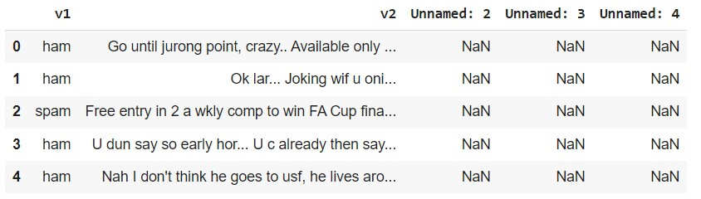

# **Question-3.** Pre processing the Dataset

Solution:

df.drop(['Unnamed: 2', 'Unnamed: 3', 'Unnamed: 4'],axis=1,inplace=True)

from wordcloud import WordCloud, STOPWORDS, ImageColorGenerator

1. = df.v2 Y = df.v1 le = LabelEncoder() Y = le.fit_transform(Y)
2. = Y.reshape(-1,1)

X_train,X_test,Y_train,Y_test = train_test_split(X,Y,test_size=0.25)

max_words = 1000 max_len = 150 tok = Tokenizer(num_words=max_words) tok.fit_on_texts(X_train)

sequences = tok.texts_to_sequences(X_train) sequences_matrix = pad_sequences(sequences,maxlen=max_len)

# **Question-4.** Create Model

Solution: inputs = Input(shape=[max_len]) layer = Embedding(max_words,50,input_length=max_len)(inputs) layer = LSTM(128)(layer) layer = Dense(128)(layer)

layer = Activation('relu')(layer) layer = Dropout(0.5)(layer) layer = Dense(1)(layer) layer = Activation('sigmoid')(layer) model = Model(inputs=inputs,outputs=layer)

# **Question-5.** Add Layers (LSTM, Dense-(Hidden Layers), Output)

Solution:

model.summary()

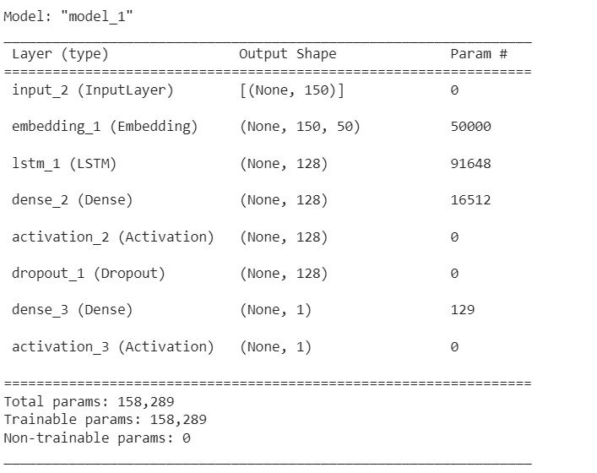

# **Question-6.** Compile the Model

Solution:

model.compile(loss='binary_crossentropy',optimizer=Adam(),metrics=['accuracy'])

# **Question-7.** Fit the Model

Solution:

history = model.fit(sequences_matrix,Y_train,batch_size=20,epochs=15, validation_split=0.2)

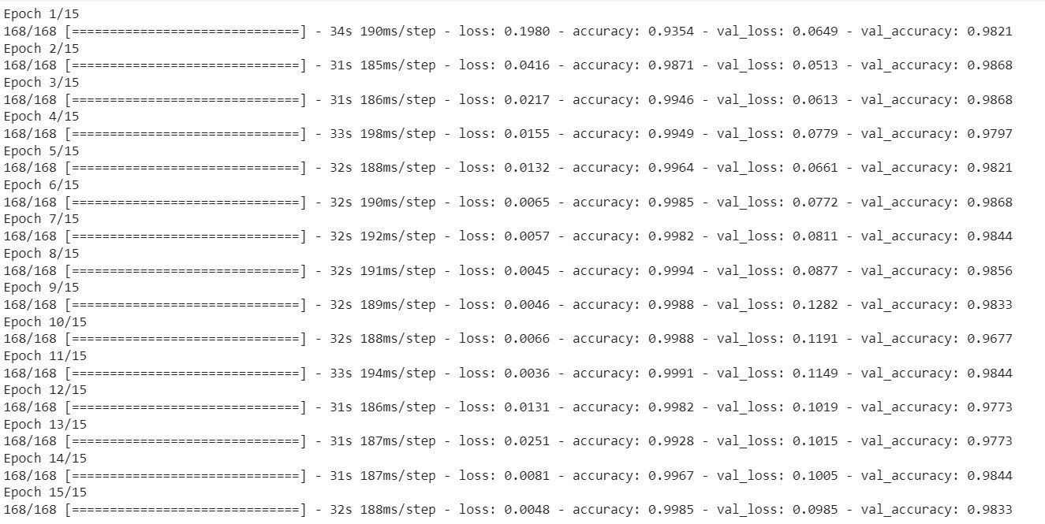

metrics = pd.DataFrame(history.history) metrics.rename(columns = {'loss': 'Training_Loss', 'accuracy': 'Training_Accuracy', 'val_loss': 'Valida tion_Loss', 'val_accuracy': 'Validation_Accuracy'}, inplace = True) def plot_graphs1(var1, var2, string):

metrics[[var1, var2]].plot()

plt.title('Training and Validation ' + string)

plt.xlabel ('Number of epochs')

plt.ylabel(string)

plt.legend([var1, var2])

plot_graphs1('Training_Accuracy', 'Validation_Accuracy', 'Accuracy')

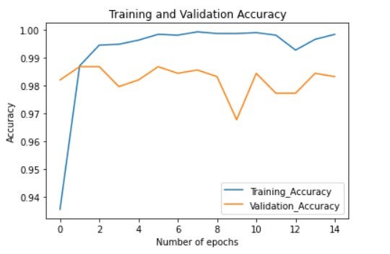

# **Question-8.** Save The Model

Solution:

model.save('Spam_sms_classifier.h5')

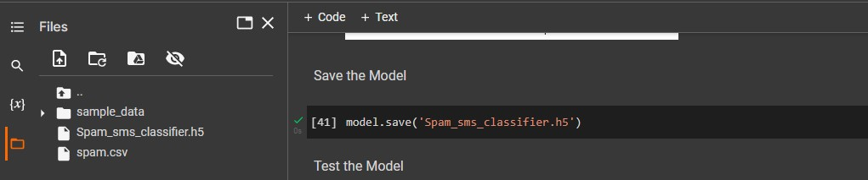

# **Question-9.** Test The Model

Solution:

test_sequences = tok.texts_to_sequences(X_test)

test_sequences_matrix = pad_sequences(test_sequences,maxlen=max_len)

accuracy1 = model.evaluate(test_sequences_matrix,Y_test)



print(' loss: {:0.4f}'.format(accuracy1[0])) print(' Accuracy: {:0.4f}'.format(accuracy1[1]))

